Q1. Consider the following patient database:
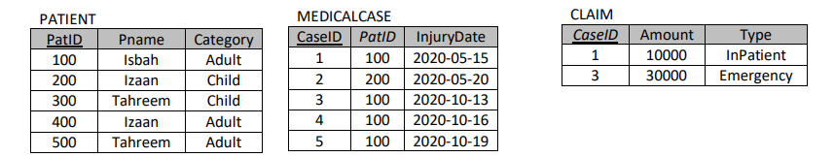
NOTE: In the above schema PKs are underline and patID in medicalcase table and caseID in claim table are Foreign Keys.
- (2 points) Give the Output of the following query for the Database State given above.
SELECT P.patID, P.Pname, P.category FROM patient AS P LEFT OUTER JOIN medicalcase AS M ON P.patID=M.patID WHERE P.category != ‘Child’ AND M.caseID IS NULL

- (2 points) Write a SQL Query to list down the name of all the patients that have claimed the medical cases above 15000 amount.

- (3 points) Apply following operations on the above patient database. State if the operation would be carried out successfully or not. In case of successful operation indicate the changes that will be made to the above database. Also state all the integrity constraints violated by each operation, if any. Please note that all operations are independent. Assume referential integrity constraint(RIC) on both FKs patID in medicalcase table and caseID in claim table are On Delete SET NULL and On Update CASCADE.

- DELETE FROM medicalcase WHERE injuryDate > ‘2020-10-13’;
- Accept
- Reject
Explain:
- DELETE FROM patient WHERE category = ’Child’;
- Accept
- Reject
Explain

- INSERT INTO medicalcase VALUES (7, null, null);
- Accept
- Reject
Explain
.
(3 points) Given the following relational state, show the result of each SQL statement.
T1
A | B
1 | 4
2 | 4
3 | 4
1 | 5
2 | 5

T2

B
3
4
5
- SELECT *
FROM T2 LEFT OUTER JOIN T1 ON T1.B=T2.B
WHERE T1.A != 1;
- (SELECT A FROM T1 UNION SELECT B FROM T2 EXCEPT SELECT B FROM T1)
INTERSECT
SELECT B FROM T2;

